Lesson 3:

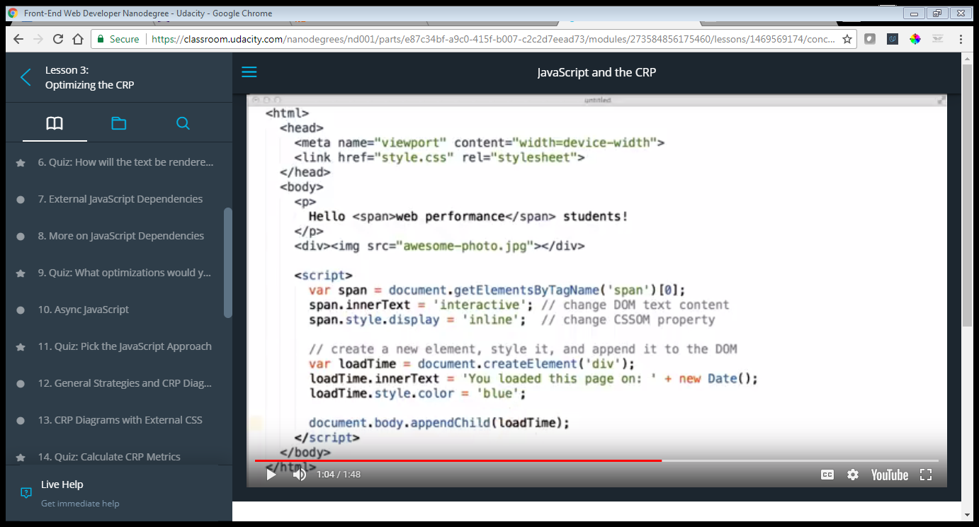

Ways to optimize web performance:

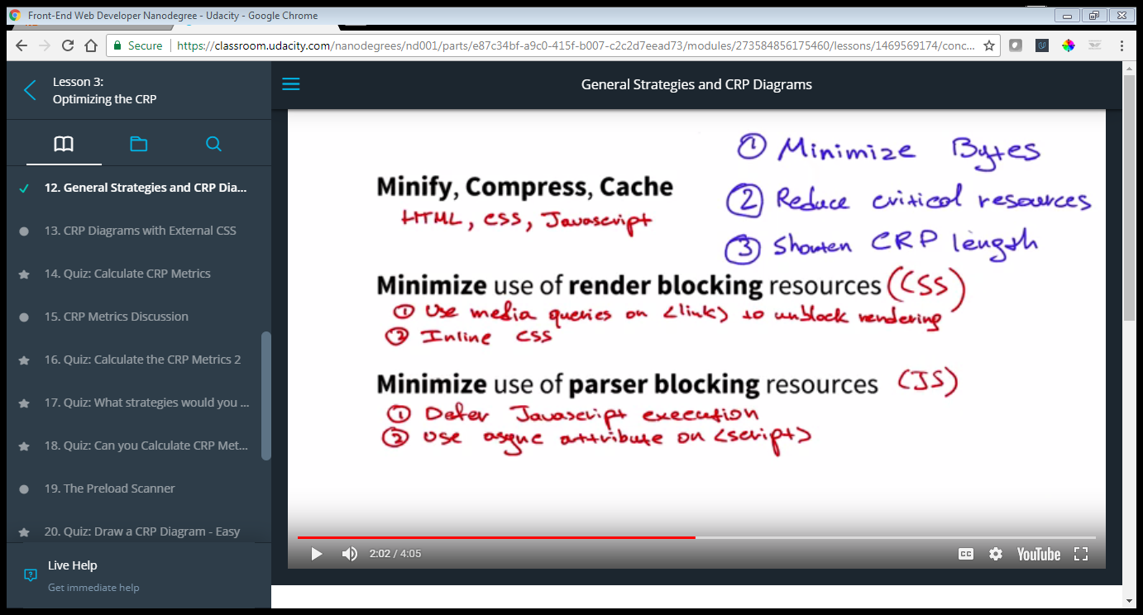

<https://developers.google.com/web/fundamentals/performance/critical-rendering-path/analyzing-crp#performance-patterns>

Critical path Diagrams:

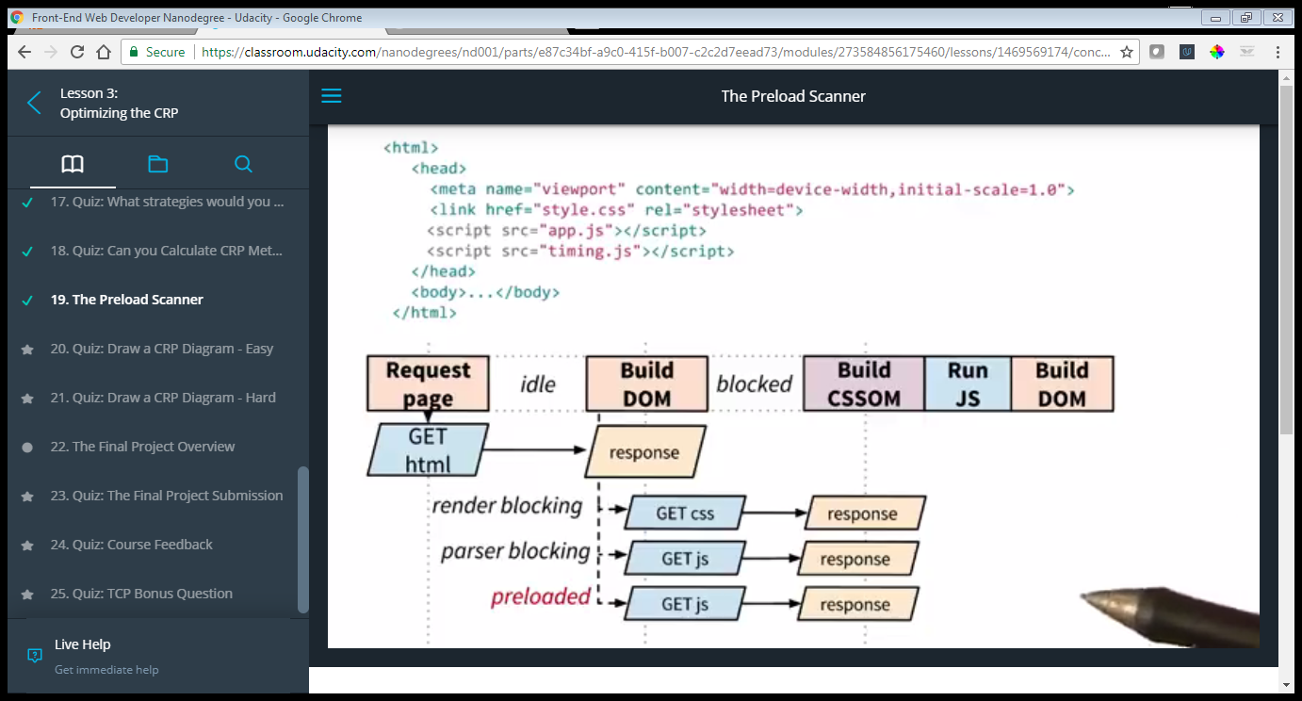

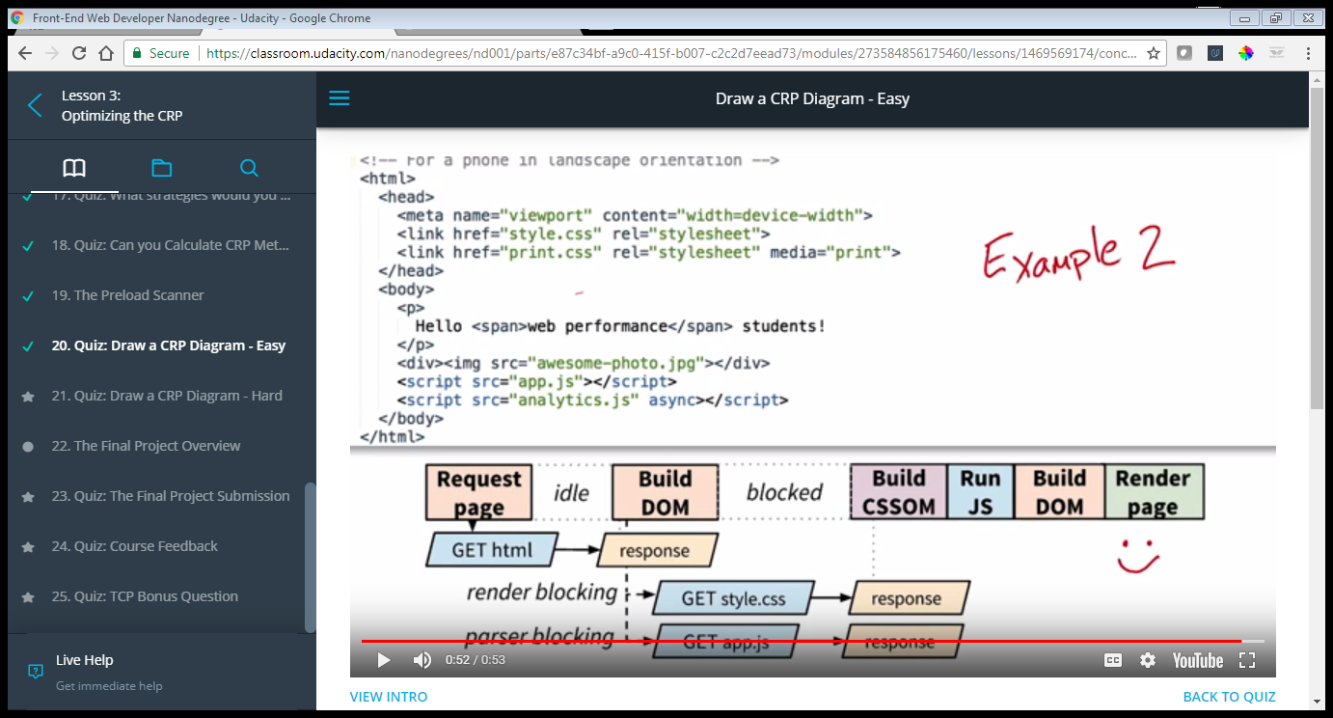

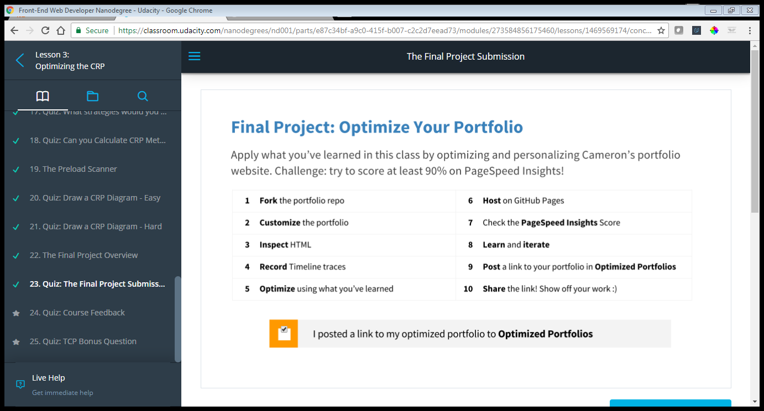

Be sure to fork the [**portfolio GitHub repo**](https://github.com/udacity/frontend-nanodegree-mobile-portfolio) with tips, tricks and hits in the documentation and check out the live version of [**Cameron's portfolio**](http://cameronwp.github.com/udportfolio).

### Using GitHub

If you are not familiar with Git and GitHub, the [**GitHub help pages**](https://help.github.com/) are a great place to start. In particular, check out the following guides: [**setup Git**](https://help.github.com/articles/set-up-git), [**fork a repo**](https://help.github.com/articles/fork-a-repo), [**hosting with GitHub Pages**](https://pages.github.com/), and the [**references section**](https://help.github.com/articles/what-are-other-good-resources-for-learning-git-and-github) to learn more.

This course teaches you how to render the first frame quickly, but what about all the frames that follow? Take [**Browser Rendering Optimization**](https://www.udacity.com/course/browser-rendering-optimization--ud860) with Cameron and [**Paul Lewis**](https://twitter.com/aerotwist) to learn how to build apps that run at 60 frames per second!

Rasterizer:

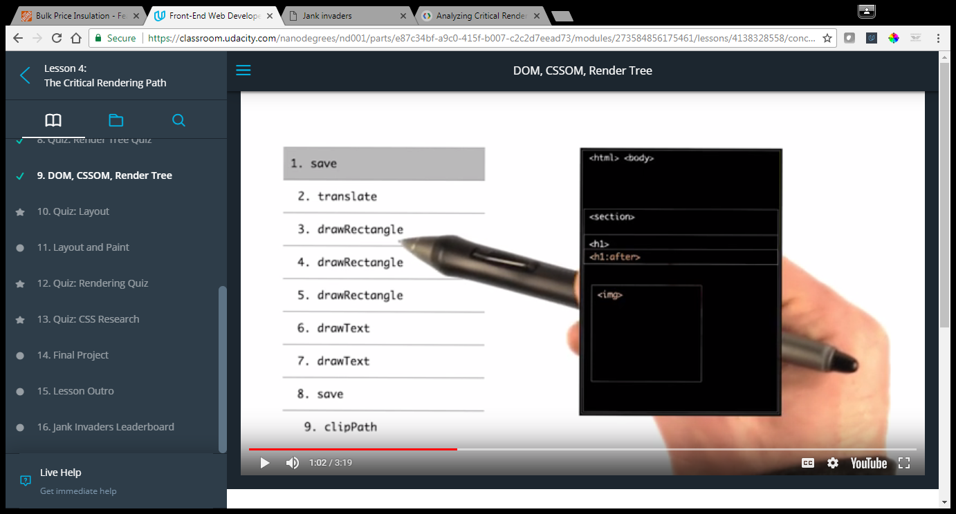

<https://csstriggers.com/>

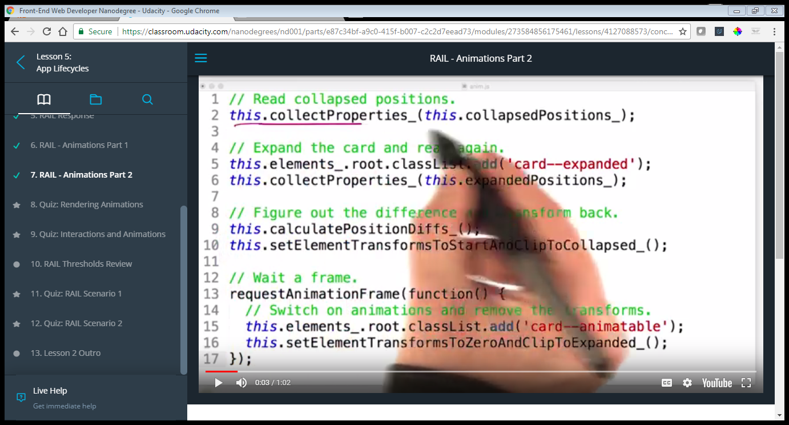

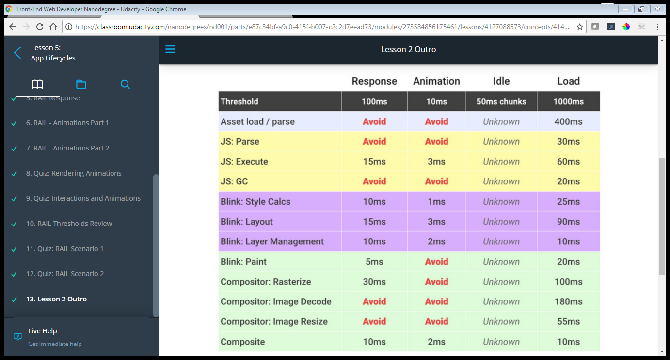

Do animation:

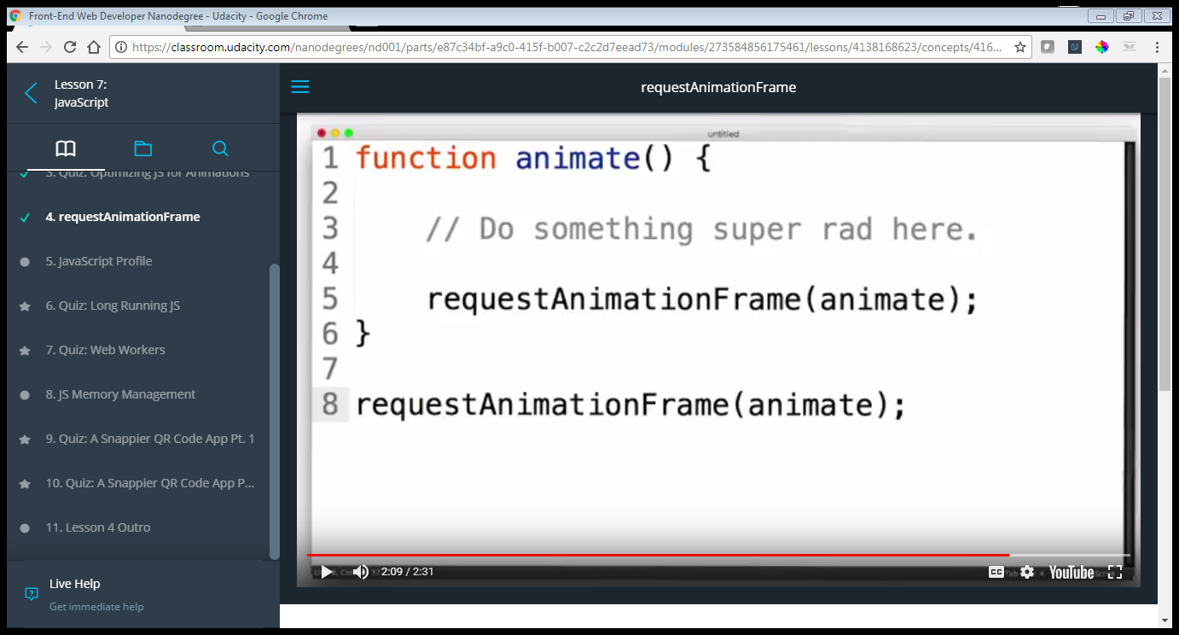

Web Worker: <https://developer.mozilla.org/en-US/docs/Web/API/Web_Workers_API/Using_web_workers>

### [Here's a link to the QR Code App repo](https://github.com/udacity/qrcode)

Build instructions:

1. Clone the repo
2. [**Install npm**](https://github.com/npm/npm)
3. [**Install Gulp**](https://github.com/gulpjs/gulp/blob/master/docs/getting-started.md)
4. Run npm install in the QR Code App directory
5. Build and run with gulp serve

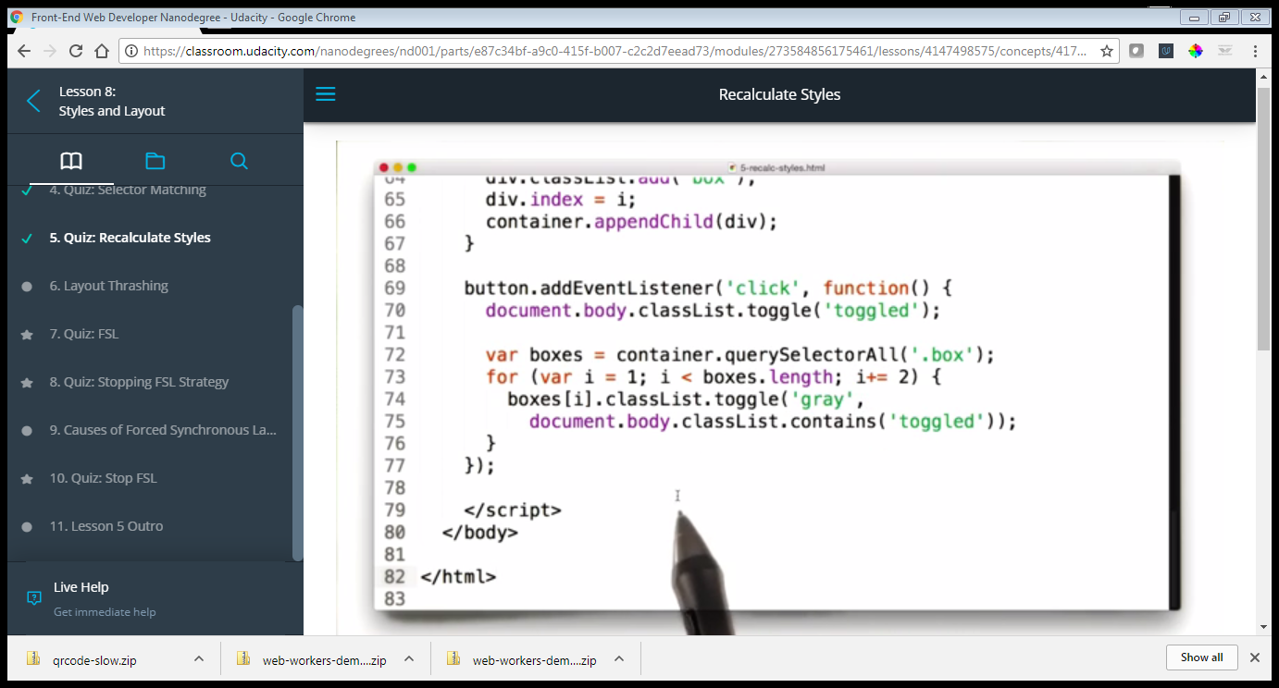

This code will force an element on its own layer

